Chapter- Interfaces

ACTIVITY 7.2

Open an application that you use frequently (for instance, a word processor, email client,

or web browser) on a PC/laptop or tablet and look at the menu header names (but do not

open them just yet). For each menu header—File, Edit, Tools, and so on—write down what

options you think are listed under each. Then look at the contents under each header. How

many options were you able to remember, and how many did you put in the wrong category?

Now try to select the correct menu header for the following options (assuming that they

are included in the application): Replace, Save, Spelling, and Sort. Did you select the correct

header each time, or did you have to browse through a number of them?

ACTIVITY 7.3

Sketch simple icons to represent the following operations to appear on a digital camera screen:

•• Turn image 90-degrees sideways.

•• Crop the image.

•• Auto-enhance the image.

••More options.

Show them to someone else, tell them that they are icons for a new digital camera

intended to be really simple to use, and see whether they can understand what each represents.

ACTIVITY 7.6

Smartwatches, such those made by Google, Apple, and Samsung, provide a multitude of functions

including fitness tracking, streaming music, texts, email, and the latest tweets. They are

also context and location aware. For example, on detecting the user’s presence, promotional

offers may be pinged to them from nearby stores, tempting them in to buy. How do you feel

about this? Do you think it is the same or worse compared to the way advertisements appear

on a user’s smartphone? Is this kind of context-based advertising ethical?

**Comment**

Smartwatches are similar to smartphones in that they, too, get pinged with promotions and

ads for nearby restaurants and stores. However, the main difference is that when worn on a

wrist, smartwatches are ever-present; the user only needs to glance down at it to notice a new

notification, whereas they have to take their phones out of their pockets and purses to see

what new item has been pinged (although some people hold their smartphone permanently in

their hands). This means that their attention is always being given to the device, which could

make them susceptible to responding to notifications and spending more money. While some

people might like to get 10 percent off on coffee if they walk into the cafe that has just sent

them a digital voucher, for others such notifications may be seen as very annoying as they are

constantly bombarded with promotions. Worse still, it could tempt children and vulnerable

people who are wearing such a watch to spend money when perhaps they shouldn’t or to nag

their parents or caretakers to buy it for them. However, smartwatch companies are aware of

this potential problem, and they provide settings that the user can change in terms of the level

and type of notifications they want to receive.

ACTIVITY 7.7

Look at the controls on your toaster (or the one in Figure 7.17 if you don’t have one nearby)

and describe what each does. Consider how these might be replaced with an LCD screen.

What would be gained and lost from changing the interface in this way?



ACTIVITY 7.5

Look at a fashion brand’s website, such as Nike, and describe the kind of interface used. How

does it contravene the design principles outlined by Jeffrey Veen? Does it matter? For what

type of user experience is it providing? What was your experience in engaging with it?

**Comment**

Fashion companies’ sites, like Nike, are often designed to be more like a cinematic experience

and use rich multimedia elements, including videos, sounds, music, animations, and interactivity.

Branding is central. In this sense, it contravenes what are considered core usability guidelines.

Specifically, the site has been designed to entice the visitor to enter the virtual store and

watch high-quality and innovative movies that show cool dudes wearing their products.

Often, multimedia interactivities are embedded into the sites to help the viewer move to other

parts of the site, for example by clicking on parts of an image or a video playing. Screen widgets

are also provided, such as menus, skip over, and next buttons. It is easy to become immersed

in the experience and forget that it is a commercial store. It is also easy to get lost and not to

know—Where am I? What’s here? Where can I go? But this is precisely what companies such

as Nike want their visitors to do and to enjoy: the experience.

Chapter Evaluation

ACTIVITY 14.1

Identify two adults and two teenagers prepared to talk with you about their Facebook usage

(these may be family members or friends). Ask them questions such as these: How often do

you look at Facebook each day? How many photos do you post? What kind of photos do you

have in your albums? What kind of photo do you have as your profile picture? How often do

you change it? How many Facebook friends do you have? What books and music do you list?

Are you a member of any groups?

ACTIVITY 14.2

What aspects would you want to evaluate for the following systems:

1. A personal music service?

2. A website for selling clothes?

**Comment**

1. You would need to discover how well users can select tracks from potentially thousands of

tunes and whether they can easily add and store new music.

2. Navigation would be a core concern for both examples. Users of a personal music service

will want to find tracks to select quickly. Users wanting to buy clothes will want to move

quickly among pages displaying clothes, comparing them, and purchasing them. In addition,

do the clothes look attractive enough to buy? Other core aspects include how trustworthy

and how secure the procedure is for taking customer credit card details.

ACTIVITY 14.3

A company is developing a new car seat to monitor whether a person is starting to fall asleep

while driving and to provide a wake-up call using olfactory and haptic feedback. Where

would you evaluate it?

**Comment**

It would be initially important to conduct lab-based experiments using a car simulator to see

the effectiveness of the new type of feedback—in a safe setting, of course! You would also

need to find a way to try to get the participants to fall asleep at the wheel. Once established as

an effective mechanism, you would then need to test it in a more natural setting, such as a race

track, airfield, or safe training circuit for new drivers, which can be controlled by the experimenter

using a dual-control car.

ACTIVITY 14.4

Perform a User Evaluation by asking 2 random students to choose a smartband for below 4000. Once they choose the devise give a debriefing asking different questions like

On scale 1-5 which of the below influenced your decision?

1. The brand & any advertisement you had seen earlier of the smart band.
2. The features available on each. Note down top 2 features which influenced the participant (also check whether the participant even remembers them)
3. How much was the participants decision influenced by the design on the smart band?

ACTIVITY 16.1

1. Use some of Budd’s heuristics to evaluate a website that you visit regularly 9or even our college website).

Do these heuristics help you to identify important usability and user experience issues?

If so, how?

2. How does being aware of the heuristics influence how you interact with the website?

3. Was it difficult to use these heuristics?

ACTIVITY 16.2

COMPARING HEURISTICS

1. Compare Nielsen’s usability heuristics with Shneiderman’s eight golden rules. Which are

similar, and which are different?

2. Then select another set of heuristics or guidelines for evaluating a system in which you are

particularly interested and add them to the comparison.

ACTIVITY 16.3

Conduct a cognitive walk-through of typical users who want to buy one of the reference books of any final year subjects as an ebook at www.amazon.com or www.flipkart.com. Check your answer with the the steps outlined earlier by Cathleen Wharton cognitive walk-though

ACTIVITY 16.4

From your experience of reading about and trying a heuristic evaluation and cognitive walkthrough,

how do you think they compare for evaluating a website in terms of the following?

1. The time typically needed to do each kind of evaluation

2. The suitability of each method for evaluating a whole website

ACTIVITY 16.5

Included below website usage report of vita.vision.org.in from Jetpack Analytics. Pl check both images & provide details on information gathered & your recommendation for site based on the same.

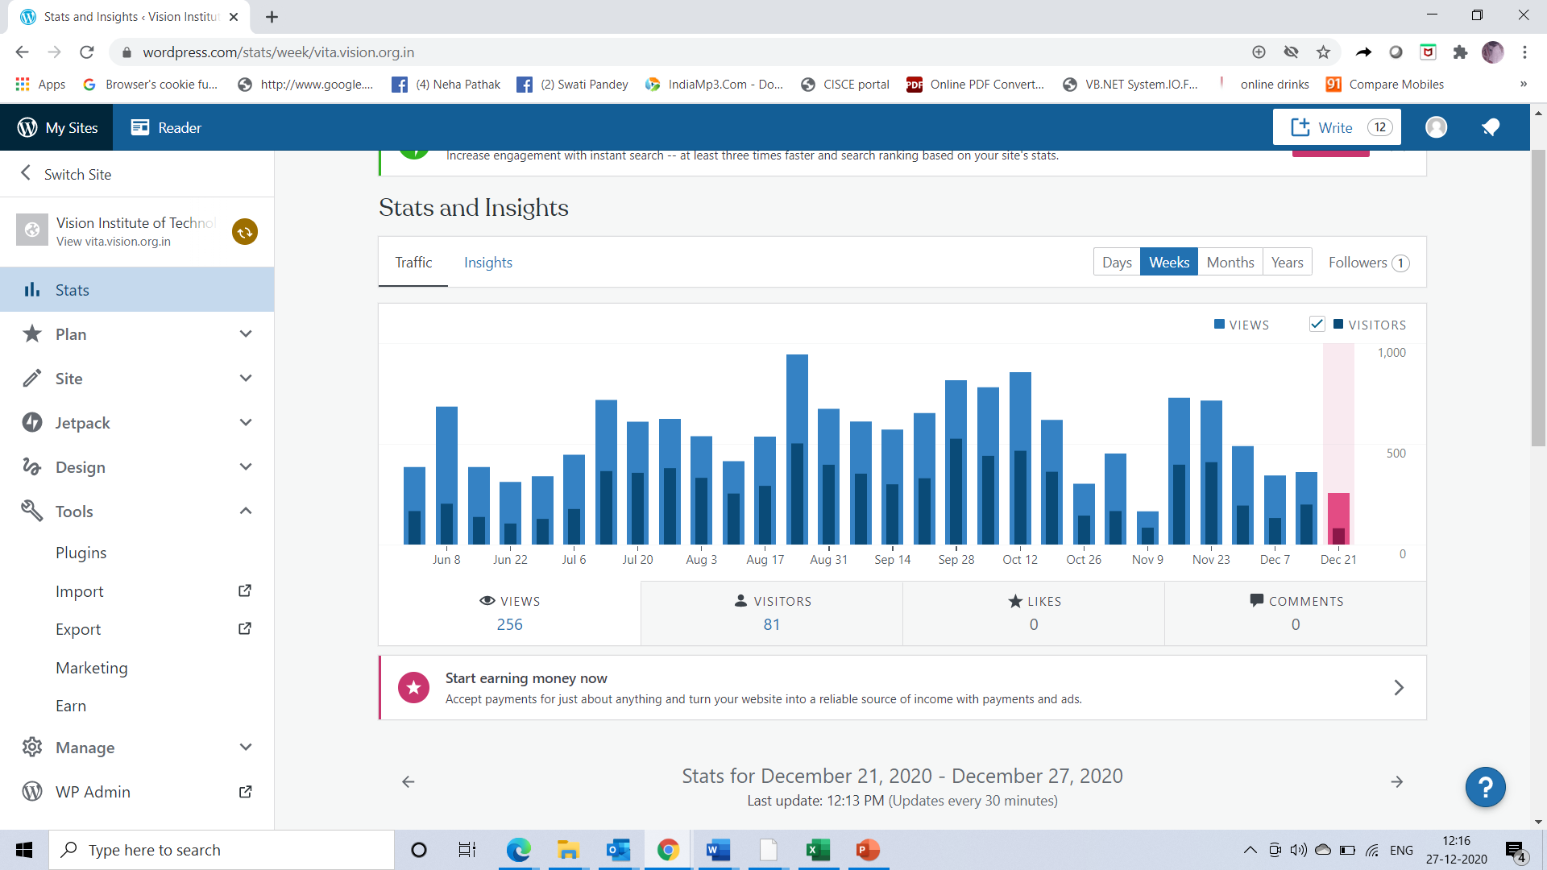

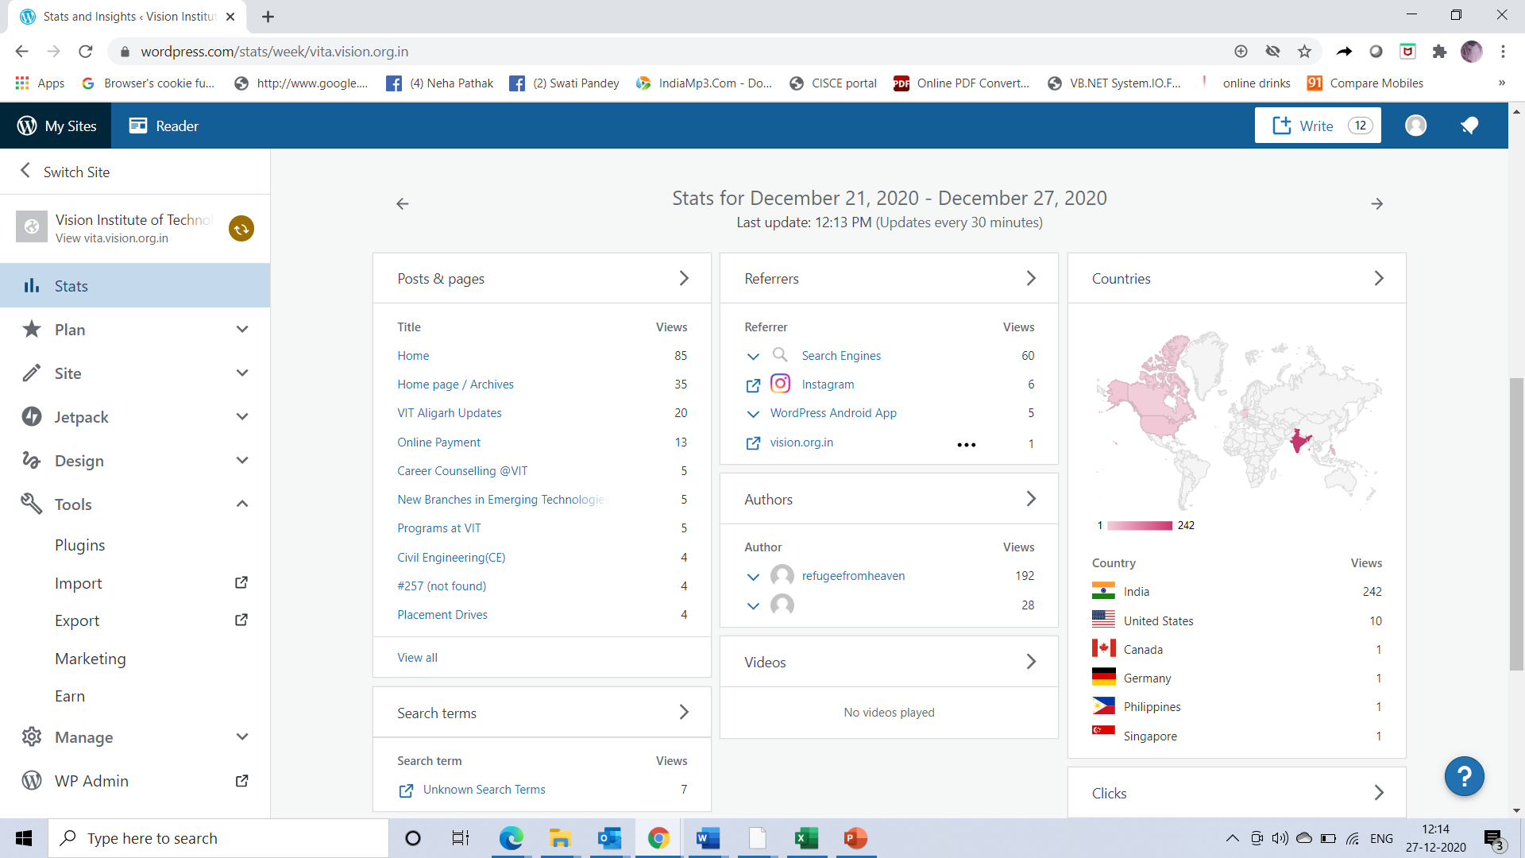

ACTIVITY 16.7

Microsoft toolbars provide the user with the option of displaying a label below each tool.

Give a reason why labeled tools may be accessed more quickly. (Assume that the user knows

the tool and does not need the label to identify it.)